Docker Task -3

Step 1:
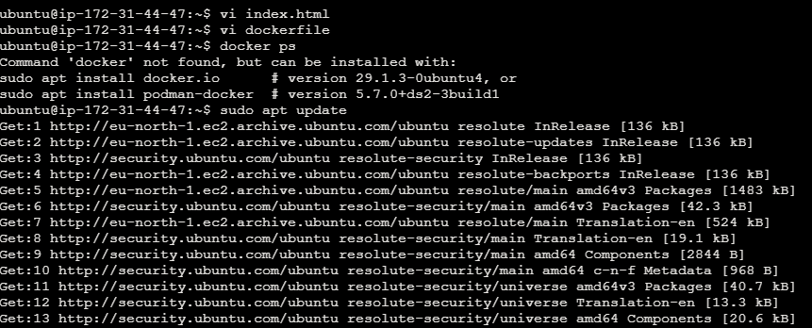

Step 2:
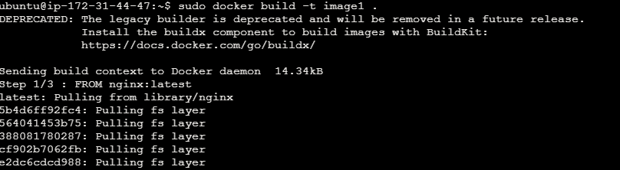

Step 3:

Step 4:
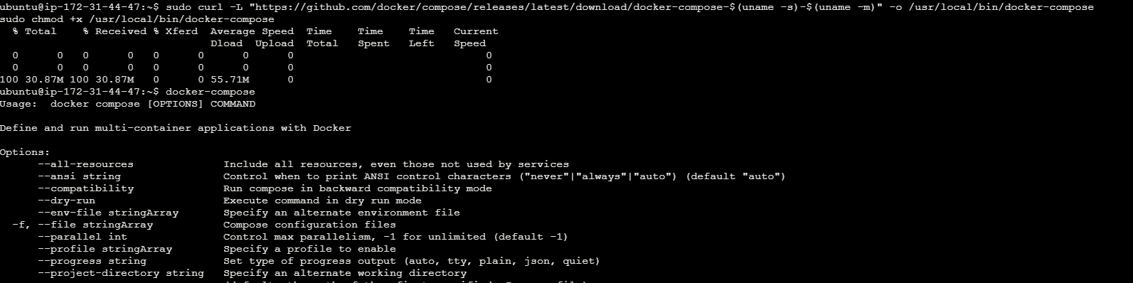
Step 5:

Step 6:
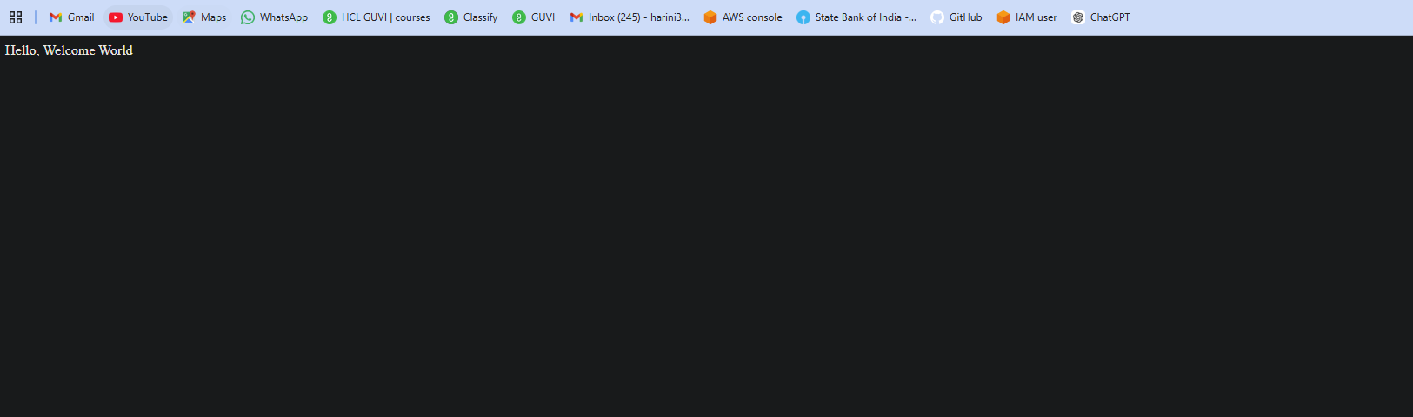
Step 7:
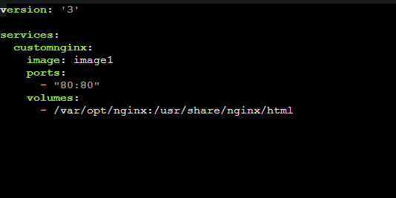

Step 8:
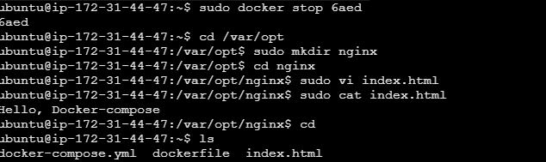

Step 9:
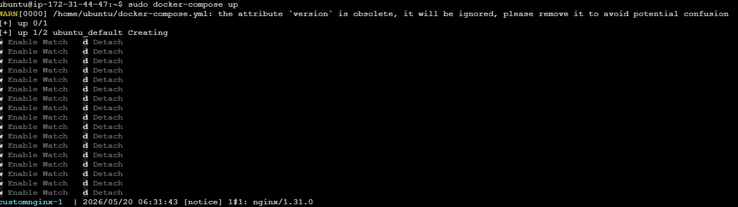

Step 10:
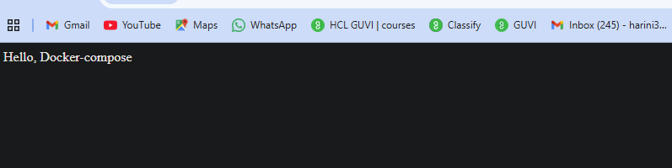

Step 11:
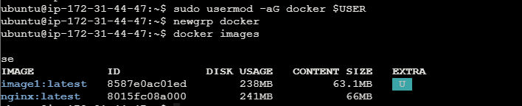

Step 12:
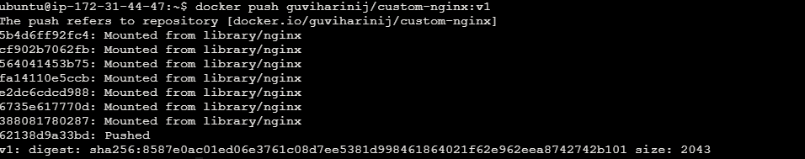

Step 13:
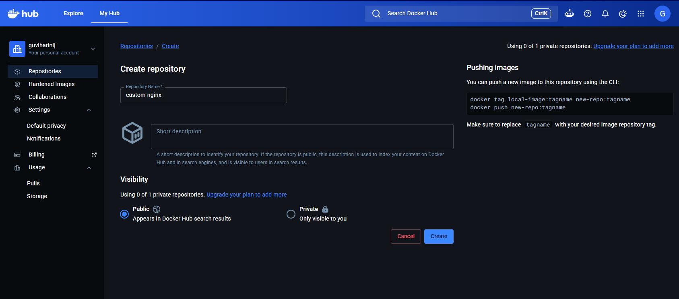

Step 14:
